GRAEME ROSE
Curriculum vitae
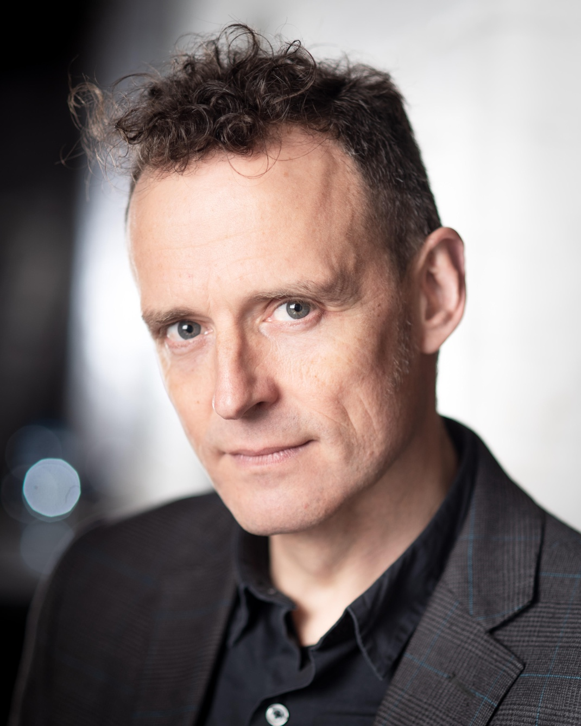

GRAEME ROSE
Curriculum Vitae

Address: 21 Abbeydale Road, Northfield, Birmingham B31 3TL
Phone: (+44) 07854 873277

E-Mail: graerose@gmail.com
Website: https://graemerose.com

DOB: 11/12/65 Birmingham, UK
Equity: M127400 Height: 5’10” Build: Slim Hair: Brown Eyes: Grey/Blue

Selected Theatre Roles
Trevor Trevor Goose & his Dark Night of Lights Talking Birds / Daimler Powerhouse, Coventry 2022
Dimitri Seeds by Nick Walker / Tabatha Mortiboy No Stone Theatre / Pleasance London 2022
Capulet Romeo & Juliet by Wm .Shakespeare Creation Digital Rep Co. 2021
Bosola The Duchess of Malfi by John Webster Creation Digital Rep Co. 2021
The Computer The Time Machine by H.G.Wells / adapt. J.Holloway Creation Theatre / London Library 2020
Pablo Picasso The Boy Who Bit Picasso by Jake Oldershaw Untied Artists / York Theatre Royal 2020
Melancholy String Q’tet’s Guide to Sex & Anxiety, dir. Calixto Bieito B’ham Rep. / Theatre de la Ville, Paris 2019
‘Sam’ (Sancho) Don Quixote adapt. from Cervantes by J.Holloway Creation Theatre / Oxford Covered Market 2019
Narrator / Detective Fred Jeffs: The Sweetshop Murder by Graeme Rose Birmingham Repertory Theatre 2018-19
Rob CHOKE! by Chris O’Connell Theatre Absolute, Shop Front, Coventry 2018
Winston Smith 1984 by George.Orwell / adapt J.Holloway Creation Theatre, Maths Institute, Oxford 2017
Jack / Aunty Marigold My Big Fat Cowpat Wedding by Sayan Kent KALI Theatre / Arts Alive! UK Rural Touring 2014-16
Sidney Carton A Tale of Two Cities by C.Dickens / adapt J.Holloway Chung Ying Theatre, Hong Kong & Pleasance Edinburgh 2016
Alan Ucard Vampomime! by Nick Walker Belgrade Theatre, Coventry 2015
Enfield / Dr. Lanyon Jekyll & Hyde by R.L.Stephenson / adapt J.Holloway Chung Ying Theatre, Hong Kong & London. 2015
The Bird Thumbelina by Dancing Brick MAC Birmingham and Brewery, Kendal. 2014
Choleric The Anatomy of Melancholy by R.Burton Stan’s Cafe, UK Tour 2013-14
Miki EAT! devised by Black Country Touring REP Birmingham, Wolverhampton and tour. 2012-13
Calystus The Cardinals devised by Stan’s Cafe France, UK, North America, Australia, Switzerland. 2011-16
Krapp Krapp’s Last Tape by Samuel Beckett Bodies In Flight, Wickham Studio, Bristol. 2011
Henry The Aspern Papers by Henry James / adapt. J Holloway Red Shift Theatre Co./ UK Tour 1998
Javert Les Miserables by Victor Hugo / adapt. J Holloway Red Shift Theatre Co. / UK Tour 1997

GRAEME ROSE
Curriculum Vitae

Resume
Founder & Company member - Glory What Glory (1988 - 1991)
Founder & Associate Artist - Stan’s Cafe Theatre (1991 to present)
Founder & Artistic Director - The Resurrectionists (1996 - 2004); later Various People Inc. [Australia]
Associate Artist - Red Shift Theatre (1997 - 2000 / 2009 -16)

Additional Performance Skills
Experience of physical theatre & dance, stage combat, puppetry; Working knowledge and interest in site-specific and immersive performance,
Range of regional / international accents; audience facilitation skills.

Musical Skills
Experience of writing/devising music-led productions, and of directing musicians, choirs and community ensembles.
Songs composed and performed in shows. Instruments played: guitar, bass guitar, basic keyboard, melodica, concertina, bugle, recorder, swanee whistle.
Band Member - The Modified Toy Orchestra (2009–13); Birmingham Town Hall, Bridgewater Hall (MCR), BBC 6Music live session with Marc Riley, 2011)

Work in Education
Co-ordinator, Stan’s Cafe (Creative Partnerships Programme 2005-6), developing teaching/learning programmes with schools across Midlands.
Developing and delivering projects from KS1-4 to F.E. (TIE tours, Arts in Education, workshops, lecturing and academic symposia.)
Taught undergraduate production modules at Universities of Birmingham, Bristol, Wolverhampton, Coventry and Hull.

Audio
Radio drama includes; Ties by Naylah Ahmed (BBC Pebble Mill, BBC R4, 2005); The Scarlet Pimpernel (Woolyback Productions, BBC R4, 2017)
BBC SoundStart / Norman Beaton Fellowship: Runner-up 2014, Finalist 2020.
Fred Jeffs: The Sweetshop Murder Podcast series, (writer / producer / presenter ) https://bctouring.co.uk/production/fred-jeffs-podcast/
SEEDS Drama Podcast developed from Theatre research project, No Stone Theatre, 2020.

Director
Directed The Furies and Journey Round My Skull (KILNensemble), The Hand That Feeds (The New Optimists) and The Head Gardener (Untied Artists).

Graeme Rose graerose@gmail.com www.graemerose.com Tel: 07854 873277

